**Lab Guide**

IBM Decision Manger Open Edition

Nigel Crowther – ncrowther@uk.ibm.com

Hands-on Guide

DMN Beyond the Basics



NOTICES

This information was developed for products and services offered in the USA.

IBM may not offer the products, services, or features discussed in this document in other countries. Consult your local IBM representative for information on the products and services currently available in your area. Any reference to an IBM product, program, or service is not intended to state or imply that only that IBM product, program, or service may be used. Any functionally equivalent product, program, or service that does not infringe any IBM intellectual property right may be used instead. However, it is the user's responsibility to evaluate and verify the operation of any non-IBM product, program, or service.

IBM may have patents or pending patent applications covering subject matter described in this document. The furnishing of this document does not grant you any license to these patents. You can send license inquiries, in writing, to:

IBM Director of Licensing

IBM Corporation

North Castle Drive, MD-NC119

Armonk, NY 10504-1785

United States of America

The following paragraph does not apply to the United Kingdom or any other country where such provisions are inconsistent with local law: INTERNATIONAL BUSINESS MACHINES CORPORATION PROVIDES THIS PUBLICATION "AS IS" WITHOUT WARRANTY OF ANY KIND, EITHER EXPRESS OR IMPLIED, INCLUDING, BUT NOT LIMITED TO, THE IMPLIED WARRANTIES OF NON-INFRINGEMENT, MERCHANTABILITY OR FITNESS FOR A PARTICULAR PURPOSE. Some states do not allow disclaimer of express or implied warranties in certain transactions, therefore, this statement may not apply to you.

This information could include technical inaccuracies or typographical errors. Changes are periodically made to the information herein; these changes will be incorporated in new editions of the publication. IBM may make improvements and/or changes in the product(s) and/or the program(s) described in this publication at any time without notice.

Any references in this information to non-IBM websites are provided for convenience only and do not in any manner serve as an endorsement of those websites. The materials at those websites are not part of the materials for this IBM product and use of those websites is at your own risk.

IBM may use or distribute any of the information you supply in any way it believes appropriate without incurring any obligation to you.

Information concerning non-IBM products was obtained from the suppliers of those products, their published announcements or other publicly available sources. IBM has not tested those products and cannot confirm the accuracy of performance, compatibility or any other claims related to non-IBM products. Questions on the capabilities of non-IBM products should be addressed to the suppliers of those products.

This information contains examples of data and reports used in daily business operations. To illustrate them as completely as possible, the examples include the names of individuals, companies, brands, and products. All of these names are fictitious and any similarity to the names and addresses used by an actual business enterprise is entirely coincidental.

**TRADEMARKS**

IBM, the IBM logo, and ibm.com are trademarks or registered trademarks of International Business Machines Corp., registered in many jurisdictions worldwide. Other product and service names might be trademarks of IBM or other companies. A current list of IBM trademarks is available on the web at “Copyright and trademark information” at www.ibm.com/legal/copytrade.shtml.

Adobe, the Adobe logo, PostScript, and the PostScript logo are either registered trademarks or trademarks of Adobe Systems Incorporated in the United States, and/or other countries.

Cell Broadband Engine is a trademark of Sony Computer Entertainment, Inc. in the United States, other countries, or both and is used under license therefrom.

Intel, Intel logo, Intel Inside, Intel Inside logo, Intel Centrino, Intel Centrino logo, Celeron, Intel Xeon, Intel SpeedStep, Itanium, and Pentium are trademarks or registered trademarks of Intel Corporation or its subsidiaries in the United States and other countries.

IT Infrastructure Library is a Registered Trade Mark of AXELOS Limited.

ITIL is a Registered Trade Mark of AXELOS Limited.

Java and all Java-based trademarks and logos are trademarks or registered trademarks of Oracle and/or its affiliates.

Linear Tape-Open, LTO, the LTO Logo, Ultrium, and the Ultrium logo are trademarks of HP, IBM Corp. and Quantum in the U.S. and other countries.

Linux is a registered trademark of Linus Torvalds in the United States, other countries, or both.

Microsoft, Windows, Windows NT, and the Windows logo are trademarks of Microsoft Corporation in the United States, other countries, or both.

UNIX is a registered trademark of The Open Group in the United States and other countries.

© Copyright International Business Machines Corporation 2020.

This document may not be reproduced in whole or in part without the prior written permission of IBM.

US Government Users Restricted Rights - Use, duplication or disclosure restricted by GSA ADP Schedule Contract with IBM Corp.

**Table of Contents**

Introduction 4

1 Why use DMN 5

2 Advanced DRD 6

3 Decision Table Hit Policies 7

3.1 Why use Hit Policies? 7

3.2 Lab 8

4 Using Data Types 9

4.1 Why use Data Types? 9

4.2 Data Type Example 9

Figure 1: Structured Versus Unstructured Data 9

4.3 Lab 9

5 Defining Logic in Feel 10

5.1 Why use Feel? 10

5.2 Lab 10

6 Conclusion 11

# Introduction

In this guide we go beyond basics of DMN to build real-world DMN.

The following topics are presented:

* **Why use DMN**
* **Advanced DRD**
* **Decision Table Hit Policies**
* **Using Data Types**
* **Advanced Feel**

By the end, you will be able to apply these real-world techniques to your DMN projects.

# Why use DMN

DMN is a decision model based on a notation standard defined by the Object Management Group (OMG)

DMN uses a graphical decision requirements diagram (DRD) that represents part or all of the overall decision requirements graph (DRG) to trace business decision flows

DMN has an underlying XML schema that allows the DMN models to be shared between DMN-compliant platforms

DMN supports Friendly Enough Expression Language (FEEL) to define decision logic in DMN decision tables and DMN boxed expressions

Use DMN if you need a standard way of creating comprehensive, illustrative, and stable decision flows

# Advanced DRD

## Going beyond basic DRD

If you are beginning your DMN journey, you probably stick with and DRD components. This is great for simple models. But if you want to unleash the full power of DRD notation, consider the components listed here:

|  |  |  |
| --- | --- | --- |
| Description | Notation | |
| Business knowledge model | Reusable function. Use this when decisions have the same logic but depend on common sub-decisions or functions. |  |
| Decision service | Top-level decision containing a set of reusable decisions published as a service for invocation. A decision service can be invoked from an external application or a BPMN business process. |  |
| Text annotation | Explanatory note associated with an input data node, decision node, business knowledge model, or knowledge source. |  |
| Knowledge source | External authorities, documents, committees, or policies that regulate a decision. This component is not executable. |  |

An example where all the DRD components are used is shown below:

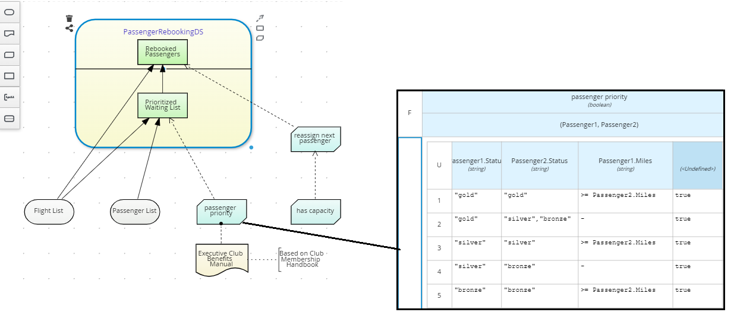

Figure 1: Advanced Passenger Booking DRD

## Lab

Open **Kie Sandbox** in Chrome:

<https://sandbox.kie.org/#/>

Create a new decision:

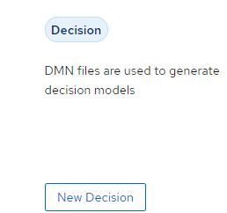

Click *New File,* thenimport the *FlightRebooking* DMN as a URL:

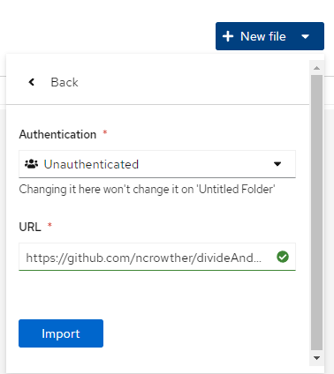

The *FlightRebooking* URL can be copied from here:

<https://github.com/ncrowther/divideAndConquerDMN/blob/main/Labs/Lab00/src/main/resources/org/acme/habitability/Lab00/FlightRebooking.dmn>

Modify the DRG so that is formatted as shown in Figure 1. (to be expanded)

Run the decision service (to be expanded)

Modify the service (to be expanded)

# Decision Table Hit Policies

Hit policies describe ways to evaluate rules contained in decision tables. Hit policies change the evaluation order of every row in a decision table. It requires different ways of reasoning over the entire table. Therefore, it is important to be able to select the right hit policy for your rule application.

## Why use Hit Policies?

Not all decisions are the same! Some decisions are top down, some count outcomes, some require traceability. You need a different hit policy for each of these.

In DMN the hit policy is specified in the top left of the decision table. See below:

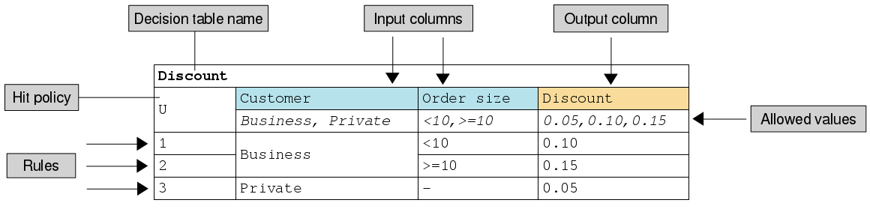

The commonly used hit policies are:

|  |  |  |
| --- | --- | --- |
| Hit Policy | Description | When to use |
| ****Unique (U)**** | Permits only one rule to match. Any overlap raises an error. | For detailed reasoning. Ensures your rules cover all cases and are complete |
| First (F) | Rules are evaluated from top to bottom. Rules may overlap, but only the first match counts. | For concise decision tables |
| ****Any (A)**** | Permits multiple rules to match, but they must all have the same output. If they do not, an error is raised. | For tables with many rows leading to identical actions |
| ****Collect (C)**** | Aggregates values in an arbitrary list. | For multiple row satisfaction. Works for strings (which are cast into a list) and numbers which can be summed, cast to a list, or return the smallest or highest number. |

Other less commonly used hit policies are **Priority**, **Rule Order** and **Output Order** which have similar behaviour to **Collect.**

## Lab

Open **Kie Sandbox** in Chrome:

<https://sandbox.kie.org/#/>

Create a new decision:



Click *New File,* thenimport the following DMN as a URL. For each hit policy, run the rules and examine the results. Which algorithm is most appropriate for this use case?

Any hit policy:

<https://github.com/ncrowther/divideAndConquerDMN/blob/main/Labs/Lab01/src/main/resources/org/acme/habitability/Lab01/HabitabilityLab00-Any.dmn>

String collection policy:

<https://github.com/ncrowther/divideAndConquerDMN/blob/main/Labs/Lab01/src/main/resources/org/acme/habitability/Lab01/HabitabilityLab00-Collect.dmn>

Numeric Count policy:

<https://github.com/ncrowther/divideAndConquerDMN/blob/main/Labs/Lab01/src/main/resources/org/acme/habitability/Lab01/HabitabilityLab00-Count.dmn>

First Policy:

<https://github.com/ncrowther/divideAndConquerDMN/blob/main/Labs/Lab01/src/main/resources/org/acme/habitability/Lab01/HabitabilityLab00-First.dmn>

Unique Policy:

<https://github.com/ncrowther/divideAndConquerDMN/blob/main/Labs/Lab01/src/main/resources/org/acme/habitability/Lab01/HabitabilityLab00-Unique.dmn>

# Using Data Types

## Why use Data Types?

The quickest win to improve DMN readability and maintainability is to replace primitive inputs with one or more data structures. This helps declutter the DMN diagram.

## Data Type Example

For example, below are two versions of a functionally identical decision service. The top DMN uses primitive attributes, the bottom DMN replaces this with a data structure which makes the design clearer and allows additional attributes to be added without changing the diagram.

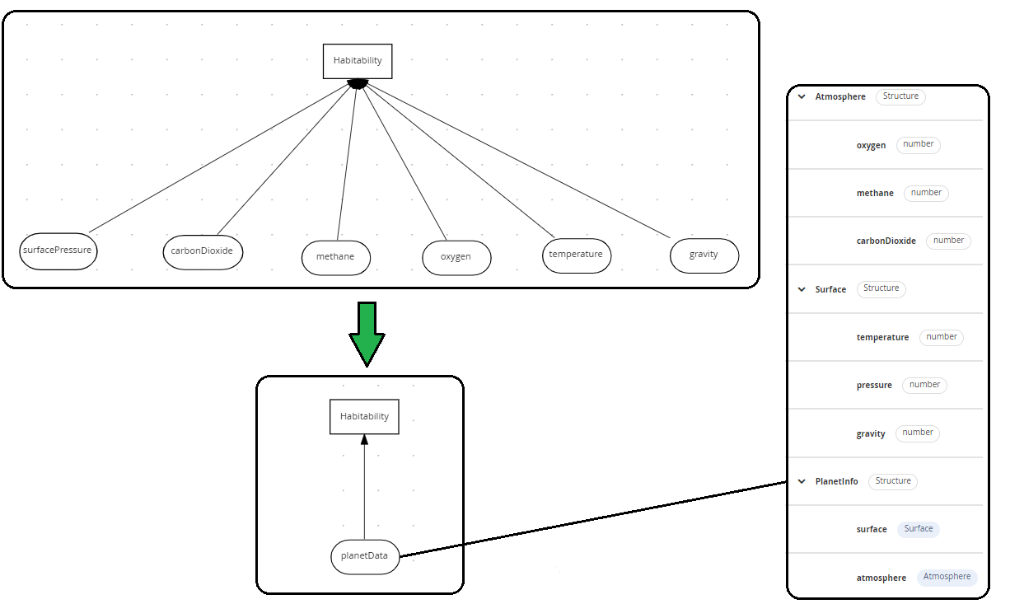

Figure 1: Structured Versus Unstructured Data

## Lab

See xxx for lab.

# Defining Logic in Feel

Friendly Enough Expression Language (FEEL) is an expression language defined by the Object Management Group (OMG). FEEL expressions define the logic of a decision in a DMN model. FEEL is designed to facilitate both decision modeling and execution by assigning semantics to the decision model constructs. FEEL expressions are written inside boxed expressions and business knowledge models.

## Why use Feel?

The following is a real-world DMN model example that demonstrates how to use FEEL to reach a complex decision. In this scenario, a flight from San Diego to New York is canceled, requiring the affected airline to find alternate arrangements for its inconvenienced passengers.

First, the airline collects the information necessary to determine how best to get the travelers to their destinations:

Input data

List of flights

List of passengers

Decisions

Prioritize the passengers who will get seats on a new flight

Determine which flights those passengers will be offered

Business knowledge models

The company process for determining passenger priority

Any flights that have space available

Company rules for determining how best to reassign inconvenienced passengers

The airline then uses the DMN standard to model its decision process in the following decision requirements diagram (DRD) for determining the best rebooking solution:

## Lab

See xxx for lab.

# Conclusion

In this lab we presented tips and techniques for building real world DMN projects. Consider applying these DMN patterns to help you scale!